**US COFEE CHAIN QLIK REPORT**

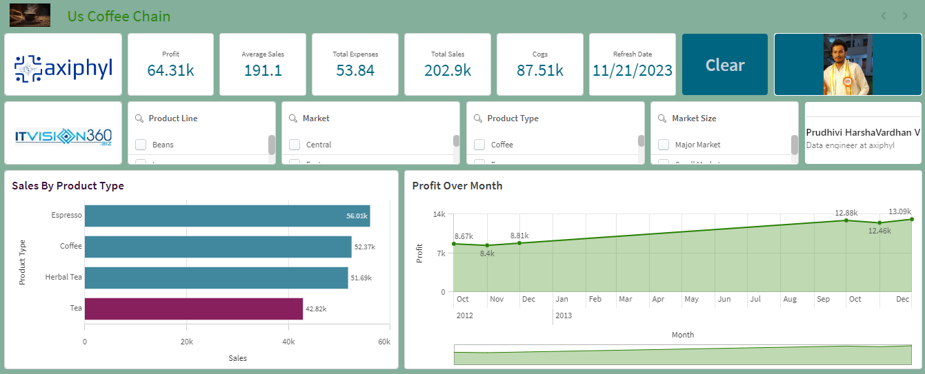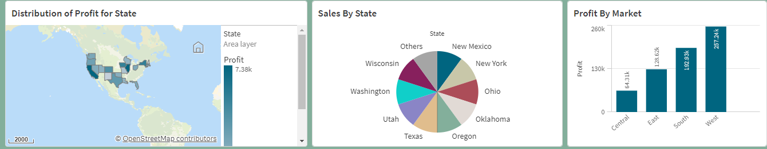

The main Objective of this report to analyse US Coffee Chain is a café That offers tea, coffee, espresso, and herbal tea in four markets over 20 states. Coffee chain offers 13 different products in 4 different categories. An understanding of the coffee chain’s process and data is required to read the report.

**Project Overview**

Data Source

Problem Statement

Key Performance Indicators (KPIs) and Data Dictionary

Executive Summary and Problems Encountered

Key Insights -Positive

Key Insights -Negative

Suggestions

Data Source

My Qlik Report consists of the following steps:

**Data collection:** Dataset has been collected from Data World.

**Data Preparation:** The dataset has been cleaned and processed for the analysis.

**Exploratory Data Analysis:** Data has been analysed to understand the sales of the US coffee chain in each state by sales and profit by calculating expenses.

**Data visualization:** we’ll Visualize the data to identify the Sales in US Coffee Chain.

**Simple Recommendation System:** Developed a visualization of sales in the US coffee chain.

 Key Performance Indicators (KPIs) and Data Dictionary

Key Performance Indicators

**Profit:** sum(profit)

**Average Sales:** Avg([total sales])

**Total Expenses:** Avg(total [Total Expenses])

**Total Sales:** sum ([Total sales])

**COGS:** sum(cogs)

**Data Dictionary**

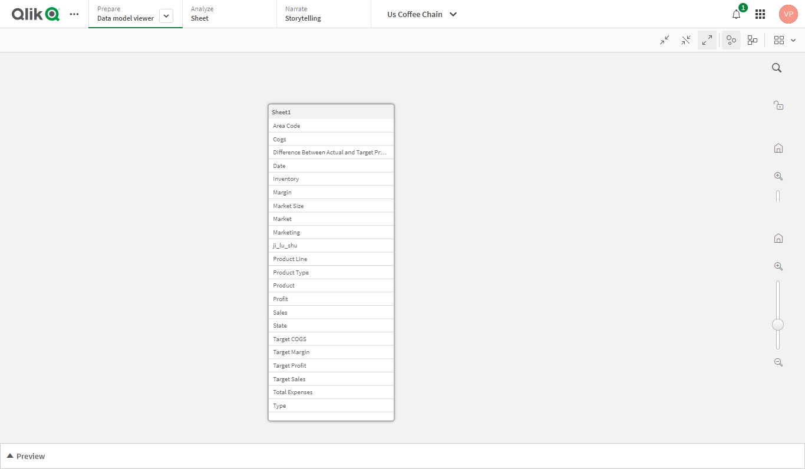

Executive Summary and Problems Encountered

The dataset contains several columns representing various attributes of the US Coffee Chain including states product types namely coffee, espresso, herbal tea, tea, sales, cogs, profit, total expenses, total sales, market, product type.

Examining price ranges and seeing any patterns or trends in sales might be part of this goal.

**Problems Encountered**

1.Choosing the correct data set was a challenge.

2.Selecting the proper KPI for the project was the other challenge. I have googled and gone through previous projects to come up with the right KPIs for the project.

3.Selecting the right KPI was the other problem occurred. MoM% was initially attempted but it does not show the desired output so there was a need to change it to YoY%.

Positive Insights:

|  |  |
| --- | --- |
| Insight | Positive |
| KPI | YOY% |
| Good or Bad | Good |
| Responsible Dim | Product Type/Year |
| More Effect Occurred | The Sales Year over Year Increased |
| The Extent of the problem | Sales by Product Type / Herbal tea |
|  | 2012 and 2013 |

Key Insights – Negatives

|  |  |
| --- | --- |
| Insight | Negative |
| KPI | GPM YOY% |
| Good or Bad | Bad |
| Responsible Dim | Gross Profit margin has been decreased |
| Where the problem occurred | Sales by Product |
| When the problem occurred | In the year 2013 |

Suggestions

As a business, increasing the business's sales and profit margins should be the top priority. Like any other retail business, the Coffee Chain needs to experience sales growth to ensure its overall long-term health.

1. A prime location with a lot of foot traffic can help make a retail store a success.  It is essential for The Coffee Chain to position its various retailers in locations where the business attracts a huge customer base as well as attracts the right sort of talent to make the business a success.
2. Another way to find out what your customer wants is by using the power of social media. The Coffee Chain page will attract more customers' attention by posting important announcements and photos**.**